# Functions

## Question: 1

Which of the following is NOT a way functions make our code more readable?

Function names can describe what the function is completing

Functions break our code into smaller, separate parts

Each function only contains one command

Functions shorten our code by reusing code that has already been written

## Question: 2

What two things must be included in your function definition?

A function name and commands to be performed

Function variables and commands to be performed

Commands to be performed and function arguments

A function name and function variables

## Question: 3

Which is the proper way to call the function three_circles?

def three_circles:

three_circles():

def three_circles():

three_circles()

# Artistic Effects

## Question: 1

How would I change Tracy’s trail to a yellow line with a thickness of 10 pixels?

Color(Yellow)

thickness(10)

color(“yellow”)

pensize(10)

color yellow()

pensize(10)

color yellow():

pensize(10)

## Question: 2

What is true of Tracy’s color command?

You can only use hex color codes

There are 10 different colors that Tracy knows

The color name must have underscores between words (ex: light_blue)

The color name must be in quotation marks

## Question: 3

What is the correct way to draw a circle that is filled in?

begin_fill()

circle(20)

end_fill()

circle(20)

begin_fill()

end_fill()

circle(begin_fill, 20, end_fill)

circle(20)

end_fill()

## Question: 4

What would be the output of the following commands?

circle(50,360,5)

1. 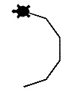
2. 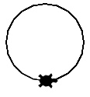
3. 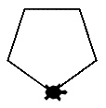
4. 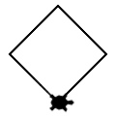

## Question: 5

What would be the output of the following commands?

circle(50,180,3)

1. 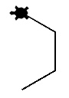
2. 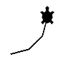
3. 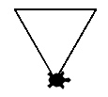
4. 